IP SOCKS

Project report submitted in fulfilment of the requirement for the degree of Bachelor of Technology

In

**Information Technology**

By

HITESH KUMAR MEENA (01520703118)

JAISAL (01720703118)

MAYANK SALAL (42320703118)

Under the supervision of

**DR.ARTI JAIN**

(Assistant Professor)



Department of Information Technology

**Netaji Subhas University of Technology (West Campus),**

**Jaffarpur, New Delhi-73**

**CANDIDATE’S DECLARATION**

I hereby declare that the work presented in this Project report entitled **“Ip Socks ”**, submitted in partial fulfillment of the requirement for the award of the degree of Bachelor of Technology in **Information Technology**, submitted to **NSUT WEST CAMPUS, India** is an authentic record of my own work carried out during the period of 7th Semester under the guidance of **DR.ARTI JAIN (Assistant Professor).**

The matter embodied in the report has not been submitted for the award of any other degree or diploma.

Dated: 1.1.2022 HITESH KUMAR MEENA (01520703118)

Place: New Delhi JAISAL (01720703118)

MAYANK SALAL (42320703118)

**ACKNOWLEDGEMENT**

I hereby Declare that all my efforts to complete my project is become possible all because of my partners who give their great contribution and support me time to time due to which I completed my project successfully. I will not have so much courage to Develop a project but due to proper corporation and guidance of my mentors and partner who will show confidence on me and Develop a courage in me to become a programmer and to develop a project which will be very helpful for other peoples also in a future life.

I will also very thankful to my mentor who will give their grateful contribution to my project. The stage at which I am standing now to develop a project is due to proper guidance, support and supervision of my mentor who will give a proper direction to my track.

I will also very thankful towards my Parents who will develop a feeling in me that I can do something in life and achieve the desired target. They will always support me at every stage and the love and encouragement of them will provided me protection layer around me which will always prevent me from going on a wrong way of life.

At last I want to thank to my college department who will give us a platform on which we will provide a shape to our dreams for making our future bright and full of happiness. As everybody knows that the life is full of competition in the today times and everybody want to get success in life and the guidelines and direction required at this stage is very necessary for achievement of the desired objectives.

**HITESH KUMAR MEENA (01520703118)**

**JAISAL (01720703118)**

**MAYANK SALAL (42320703118)**

**Abstract**

The Tor project is a non-profit organisation that conducts research and development into online privacy and anonymity. It is designed to stop people – including government agencies and corporations – learning your location or tracking your browsing habits.

Based on that research, it offers a technology that bounces internet users' and websites' traffic through "relays" run by thousands of volunteers around the world, making it extremely hard for anyone to identify the source of the information or the location of the user.

Its software package – the Tor browser bundle – can be downloaded and used to take advantage of that technology, with a separate version available for Android smartphones.

**AIM OF STUDY**

The purpose of TOR is to specify the amount and type of work to be accomplished by the project. It is a governance document that establishes and determines the relationships between all project stakeholders. Terms of Reference are developed once a project has been identified, defined and planned.

Tor, short for The Onion Router, is free and open-source software for enabling anonymous communication. It directs Internet traffic through a free, worldwide, volunteer overlay network, consisting of more than six thousand relays, for concealing a user's location and usage from anyone conducting network surveillance or traffic analysis. Using Tor makes it more difficult to trace the Internet activity to the user. Tor's intended use is to protect the personal privacy of its users, as well as their freedom and ability to conduct confidential communication by keeping their Internet activities unmonitored.

Tor enables its users to surf the Internet, chat and send instant messages anonymously, and is used by a wide variety of people for both licit and illicit purposes.Tor has, for example, been used by criminal enterprises, hacktivism groups, and law enforcement agencies at cross purposes, sometimes simultaneously;likewise, agencies within the U.S. government variously fund Tor (the U.S. State Department, the National Science Foundation, and – through the Broadcasting Board of Governors, which itself partially funded Tor until October 2012 – Radio Free Asia) and seek to subvert it.

Tor is not meant to completely solve the issue of anonymity on the web. Tor is not designed to completely erase tracks but instead to reduce the likelihood for sites to trace actions and data back to the user.

**CONTENTS**

**Certificate……………………………………………………………………i**

**Candidate’s Declaration……………………………………………………ii**

**Acknowledgement…………………………………………………………..iii**

**Abstract……………………………………………………………………...iv**

**Aim of study…………………………………………………………………v**

**Chapter 1 INTRODUCTION……………………………………07**

* 1. Project Overview…………………………………07
  2. About the Application.................………………...07
  3. Uses of Application................................................10
  4. Working of project……………………………….10

**Chapter 2 CODING……………………………………………….12**

**2.1** Install.py.................................................................12

**2.2** Tor.py.....................................................................13

**INTRODUCTION**

* **PROJECT OVERVIEW**

Tor Browser uses the Tor network to protect your privacy and anonymity. Using the Tor network has two main properties:

* Your internet service provider, and anyone watching your connection locally, will not be able to track your internet activity, including the names and addresses of the websites you visit.
* The operators of the websites and services that you use, and anyone watching them, will see a connection coming from the Tor network instead of your real Internet (IP) address, and will not know who you are unless you explicitly identify yourself.
* **ABOUT THE APPLICATION**

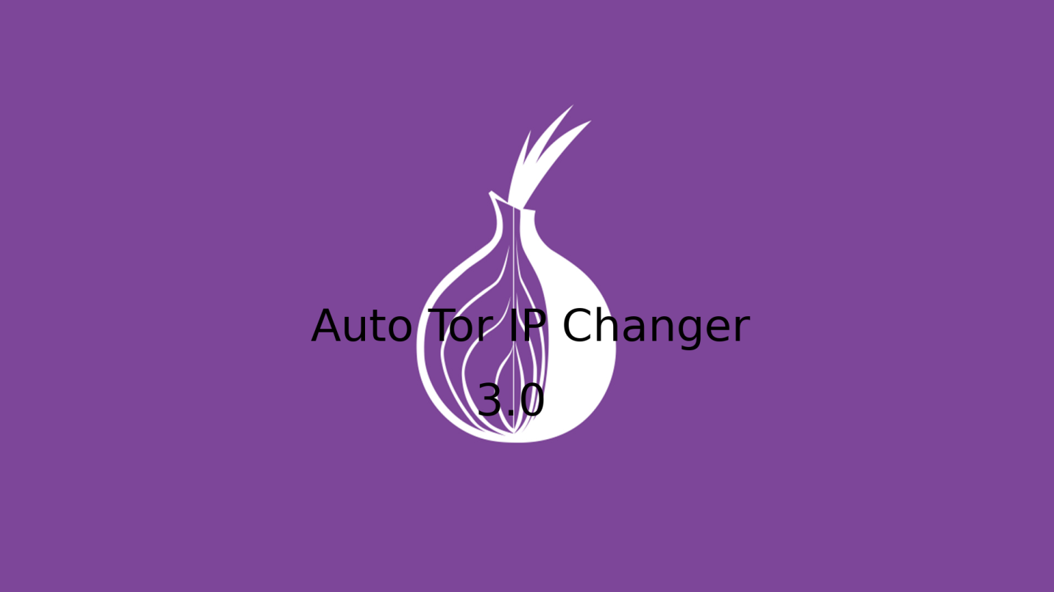

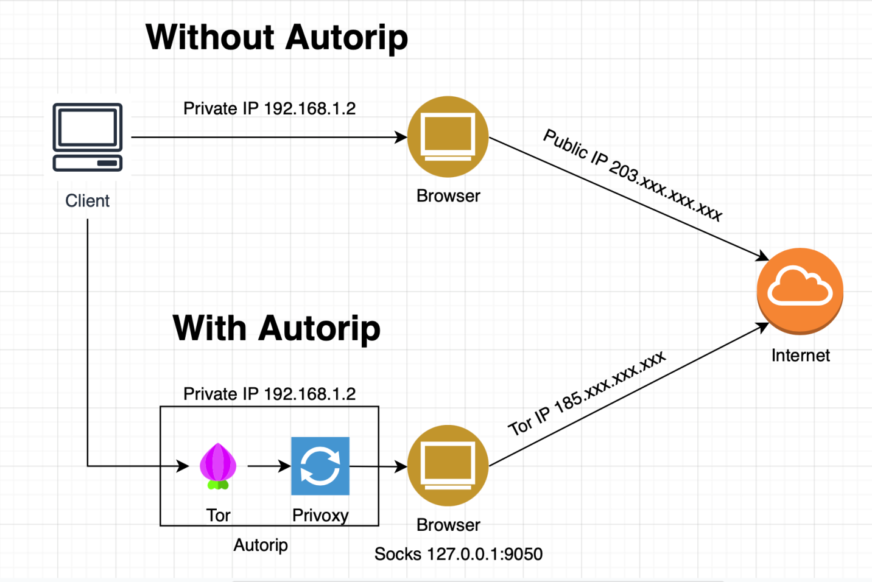

**Tor is a anonymity network.This network also provide us secure connection and secure browsing.we can browse any website anonymously.Our internet traffic is encryted. Anyone can't monitor our browsing history ,download and protect to tracking.I have create a auto_tor_ip changer script.This is a python program.This program can automatic change our tor idenity/ip.**

**At first,We need to open the firefox browser and configuring SOCKS Proxy in firefox.**

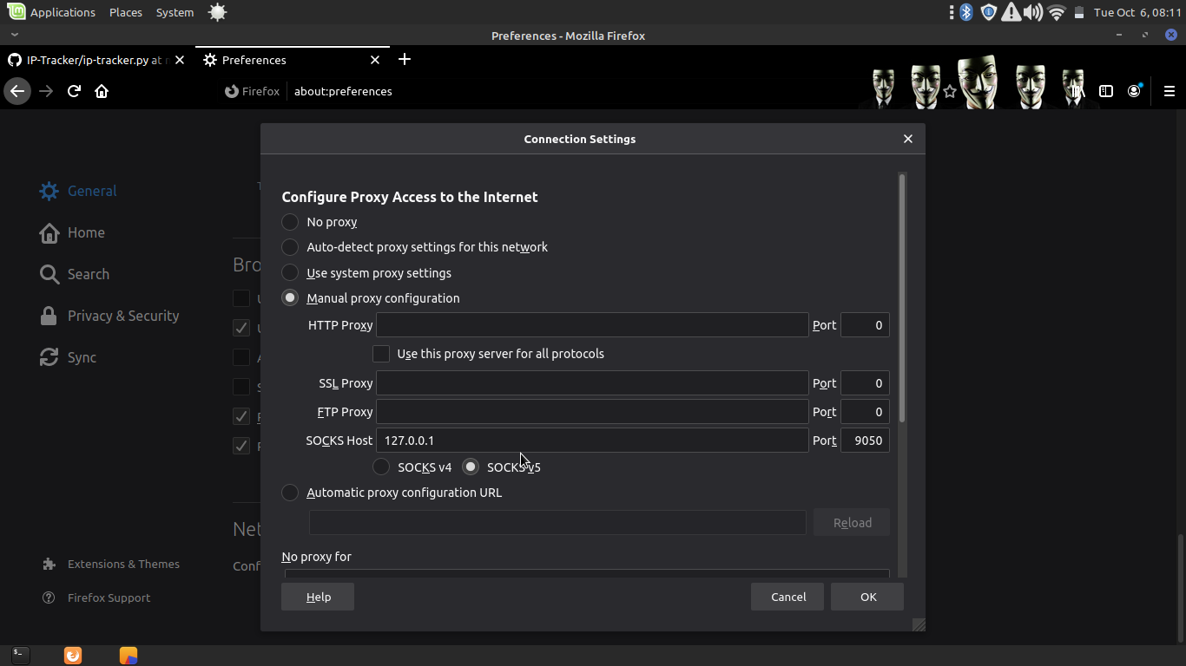

**We need to install Tor on our system. Open a terminal and type the following command to install it:**

**$ sudo apt install tor**

**Now,we have started tor network.Open a terminal and type the following command :**

**$ sudo service tor start**

**[Setup]**

* **sudo apt install python3-setuptools**
* **sudo pip3 install requirements.txt**
* **sudo apt install python3-socks**

**[Getting started]**

* **git clone https://github.com/Hiteshmeena07/Ip_Socks**
* **cd Ip_Socks**
* **sudo python3 tor.py**

**[Tested On]**

* **Ubuntu**
* **Kali Linux**
* **Linuxmint**
* **Parrot Os**
* **BackBox**
  + **Uses of Application**
* Hides your online activity. Your browsing history and cookies are automatically reset when you stop using it.
* Anti-spy protection. Tor prevents others from tracking the websites you visit.
* Anonymous identity. Tor tries to make all users look-alike to stop anyone identifying you from the characteristics of your browser or devices.
* Multi-layer encryption. In the Tor network, your traffic is redirected and encrypted several times to keep you totally anonymous.
* Free access. The Tor browser allows you access to websites blocked by your network.
* **WORKING OF PROJECT**

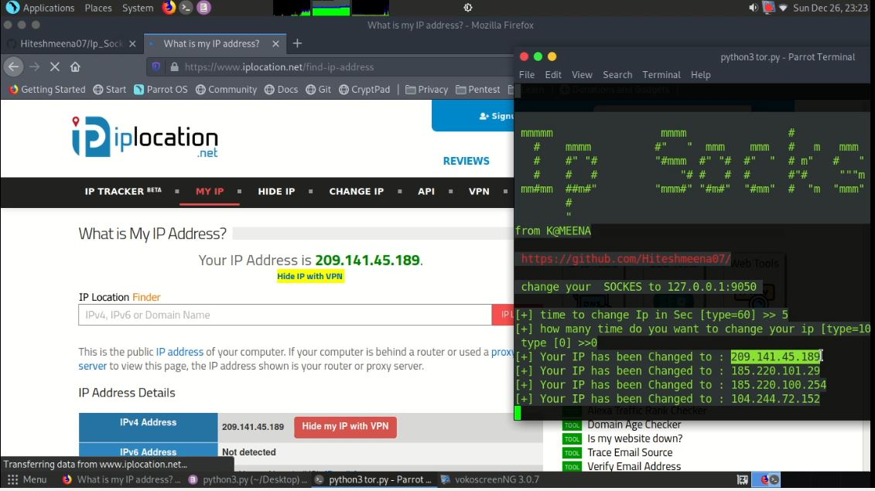

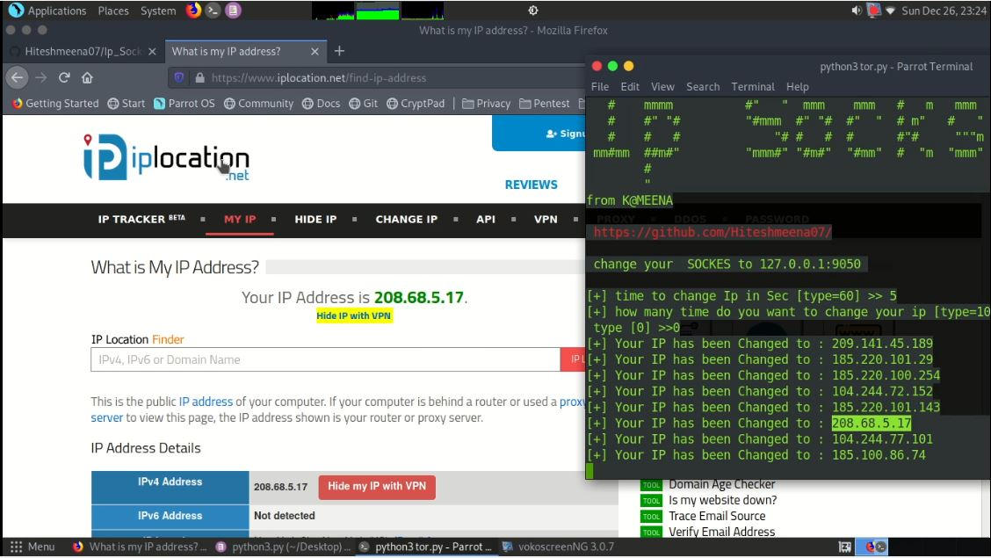

* **CODING**

**Install.py**

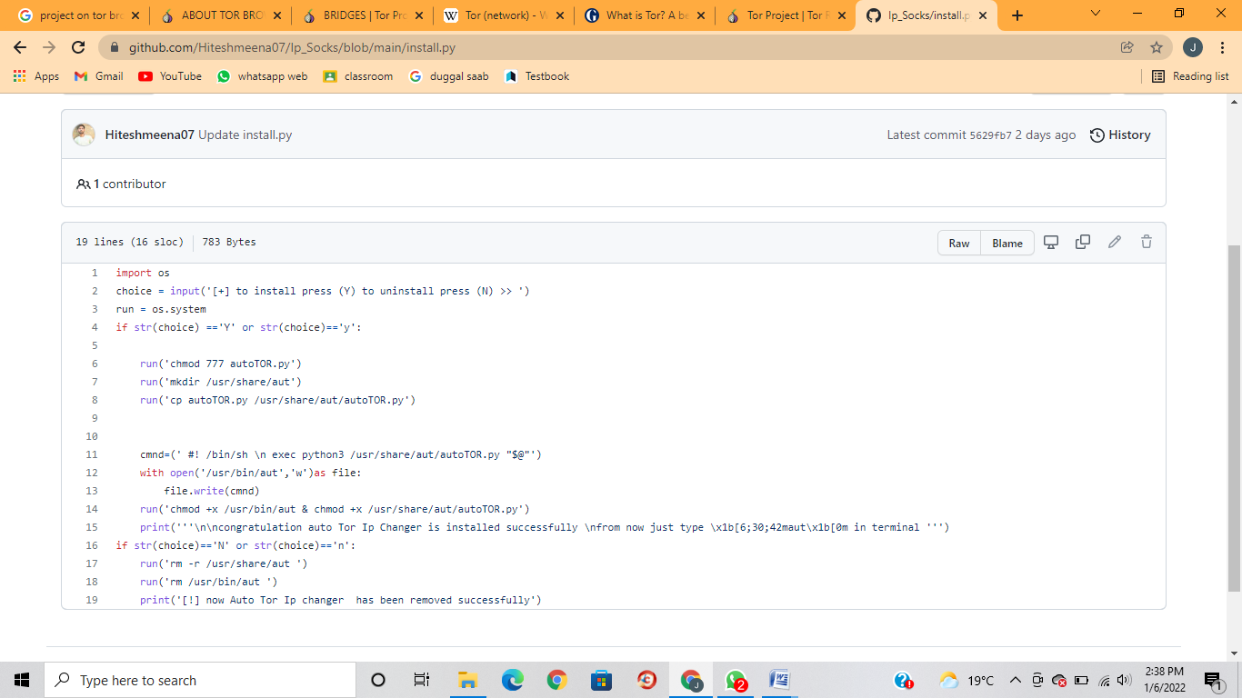

**Tor.py**



